MINISTRY OF EDUCATION & TRAINING
HO CHI MINH CITY UNIVERSITY OF ECONOMICS AND FINANCE

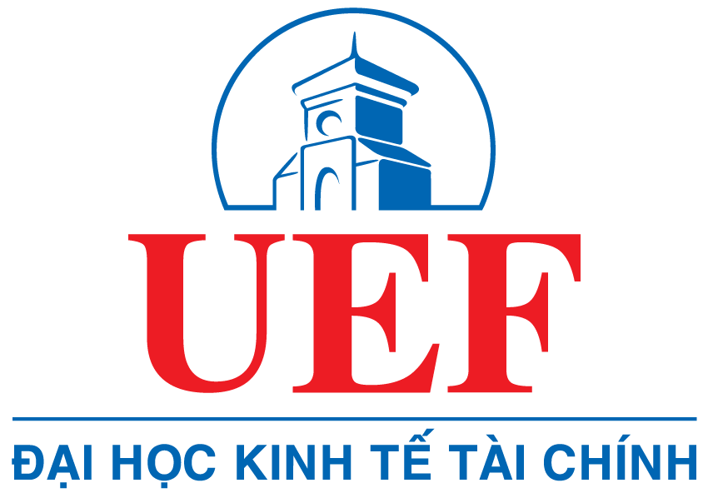

FINAL PROJECT
Course: 2024-2025
Course code:

FINAL PROJECT NAME

Student’s Name:

Student ID :

Class :

MINISTRY OF EDUCATION & TRAINING
HO CHI MINH CITY UNIVERSITY OF ECONOMICS AND FINANCE

FINAL PROJECT
Course: 2024-2025
Course code:

FINAL PROJECT NAME

Student’s Name:

Instructor:

ACKNOWLEDGEMENT

